**Association between clinical-pathological features and BRCA 1\2 mutation in women with epithelial ovarian cancer**

…, …, …, 2Davide Guido, 3Pia Clara Pafundi, 2Luciano Giacò, …, …

2Facility of Bioinformatics, Fondazione Policlinico Universitario Agostino Gemelli IRCCS, Rome, Italy

3Facility of Epidemiology and Biostatistics, Fondazione Policlinico Universitario Agostino Gemelli IRCCS, Rome, Italy

In verde la biblio, in giallo le cose da sistemare

**Abstract**

**Background:**…

**Materials and methods:**…

**Results:…**

**Conclusions:….**

**Introduction**

…

The aim of this study is to investigate potential associations between BRCA status and histopathologic features (i.e., molecular markers), in patients with primary advanced ovarian cancer.

**Materials and methods**

…

*Study design*

This observational retrospective cohort study included 202 subjects. In depth, we enrolled patients with high grade serous ovarian cancer admitted to Gynaecologic Oncology Unit of “Policlinico Universitario Agostino Gemelli” (Rome) between 2014 and 2019 with either known BRCA 1/2 germline or somatic mutation status with known histopathologic and molecular features. All patients provided informed consent to the use of their samples for research purposes. In the case of paraffin-embedded samples unavailable for histological analyses, subjects were excluded. Histopathologic features will be reviewed and stratified in an electronic database. The flow-chart of the study is reported in Figure 1.

The study was designed in accordance with 1976 Declaration of Helsinki and its later amendments and was approved by our local Ethics Committee.

**Figure 1. Flow chart of the study**

*Endpoints*

…

*Statistical analysis*

Preliminary, descriptive statistics were computed both on overall population and strata related to BRCA mutation (wild-type vs. BRCA 1 vs. BRCA 2 or wild-type vs. BRCA mutated). Qualitative data were expressed as absolute and percentage frequencies, whilst quantitative variables either as mean and standard deviation (SD) or as median and interquartile range (IQR), after assessment of distribution by the Shapiro Wilk test. As for quantitative variables, between groups differences were assessed either by ANOVA or Kruskal-Wallis test across the three sub-populations, and by Student t test or Mann Withney U test in case of two sub-populations. Chi-squared test was instead applied on qualitative data.

The pairwise associations between molecular markers was assessed through Spearman correlation coefficients (r), on both whole and BRCA-stratified population. Correlation test and relative P-values and 95% confidence intervals (95%CI) were also computed. In addition, correlation heatmaps were drawn for an instant visualization and comparison between associations.

Statistical significance was set at P value < 0.05. P values between 0.05 and 0.10 were also reported as suggestive. All analyses were performed by using R software (v. 4.1.2, R Core Team, 2020) and its packages Hmisc (Harrell Jr, 2021) and ggplot2 (Wickham, 2016).

**Results**

Overall, 202 women were finally included in the study, of which 132 were BRCA wild-type, 44 BRCA 1 and 26 BRCA 2. As for molecular markers (MM), a suggestive finding emerged towards a lower Nucleus ER-β1 score in BRCA 2 women (p=0.079), whilst no significant difference emerged as for the other MM.

Table 2 shows the Spearman correlation pattern among molecular markers, both overall and stratified according to BRCA molecular pattern, i.e. BRCA wild-type vs. BRCA 1 vs. BRCA 2, further depicted in the heatmap presented in Figure 2.

Indeed, looking at BRCA wt vs. BRCA mutated (BRCA 1 or BRCA 2), these latter were significantly younger (p=0.012), but no significant difference emerged as for the other MM. The whole data are reported in Table 3.

As for the three subpopulation, Spearman correlation pattern was computed, as reported in Table 4 and Figure 3.

**PER I CLINICI: RIPORTARE I RISULTATI SIGNIFICATIVI STATISTICAMENTE DELLA TABELLA 3 CHE HANNO UN RISCONTRO CLINICO E SOPRATTUTTO SU CUI SI VUOLE INSISTERE NELLA DISCUSSIONE.**

It is worth to point out that the significances of the correlation analysis are dependent from sample size, hence comparisons between BRCA strata should be considered with caution.

|  |  |  |  |  |  |
| --- | --- | --- | --- | --- | --- |
| **Table 1.** General characteristics of the study population (n=202).* | | | | | |
|  | **Overall** | **BRCA mutation** | | | |
|  |  | **wtBRCA**  **(n=132)** | **BRCA 1**  **(n=44)** | **BRCA 2**  **(n=26)** | **p\*\*** |
| Age (yrs.) | 59.1 (11.5) | 60.5 (11.4) | 54.7 (10.8) | 59.7 (11.2) | **0.009** |
| Nucleus AR score | 0 (0-2) | 0 (0-2) | 0 (0-2) | 0 (0–4) | 0.920 |
| PR score | 1 (0-3) | 1 (0-2.5) | 1.5 (0-5) | 1 (0-3) | 0.268 |
| ER-α score | 4 (2-8) | 4 (2-8) | 4 (2-6) | 3 (1-6) | 0.184 |
| Nucleus ER-β1 score | 4 (3-8) | 5 (3-8) | 5 (3-8) | 3 (2-8) | *0.079* |
| Cytoplasm ER-β1 score | 3 (0-3) | 3 (0-3) | 2.5 (0-4) | 1 (0-3) | 0.297 |
| Nucleus ER-β2 score | 8 (4-8) | 7.1 (3.3) | 6.8 (3.4) | 7 (3.3) | 0.811 |
| Cytoplasm ER-β2 score | 2 (0-3) | 2 (0-3) | 2.5 (0-3) | 0 (0-3) | 0.154 |
| Nucleus ER-β5 score | 6 (4-8) | 6.3 (2.8) | 5.9 (3.4) | 5.7 (3.2) | 0.334 |
| Cytoplasm ER-β5 score | 0 (0-3) | 0 (0-3) | 0 (0-3) | 0 (0-0) | 0.662 |
| ER-α/Nucleus ER-β1 ratio | 0.8 (0.4-2.0) | 0.9 (0.3-2.0) | 0.8 (0.4-1.2) | 0.8 (0.3-2.0) | 0.814 |
| ER-α/Nucleus ER-β2 ratio | 0.7 (0.3-1.1) | 0.7 (0.3-1.3) | 0.7 (0.3-1.0) | 0.5 (0.3-0.8) | 0.415 |
| ER-α/Nucleus ER-β5 ratio | 0.8 (0.3-1.3) | 0.8 (0.3-1.3) | 0.8 (0.4-1.5) | 0.5 (0.3-1.0) | 0.637 |
| **Abbreviations**: wt: wild-type; AR: androgen receptor; PR: progesterone receptor; ER: oestrogen receptor;  * Descriptive statistics are expressed as median [interquartile range] or mean (standard deviation)  ** p-values were computed by ANOVA (if normally distributed) or Kruskal-Wallis test were used | | | | | |

|  |  |  |  |  |  |  |  |  |  |
| --- | --- | --- | --- | --- | --- | --- | --- | --- | --- |
| **Table 2. Association analysis of the molecular markers stratified according to BRCA molecular pattern, both overall and in BRCA-wt, BRCA 1 and BRCA 2, respectively (n =202).** | | | | | | | | | |
| **OVERALL** | **Nucleus AR score** | **PR score** | **ER-α score** | **Nucleus**  **ER-β1 score** | **Cytoplasm**  **ER-β1 score** | **Nucleus**  **ER-β2 score** | **Cytoplasm**  **ER-β2 score** | **Nucleus**  **ER-β5 score** | **Cytoplasm**  **ER-β2 score** |
| **PR score** | **0.369 (0.242; 0.506)**  **<0.001** | - |  |  |  |  |  |  |  |
| **ER-α score** | **0.255 (0.130; 0.377)**  **<0.001** | -0.017 (-0.161; 0.126)  0.809 | - |  |  |  |  |  |  |
| **Nucleus ER-β1 score** | *0.13 (-0.002; 0.248)*  *0.070* | 0.017 (-0.120; 0.149)  0.809 | -0.004 (-0.130; 0.134)  0.959 | - |  |  |  |  |  |
| **Cytoplasm ER-β1 score** | 0.031 (-0.112; 0.170)  0.666 | -0.000 (-0.141; 0.142)  0.995 | **0.170 (0.031; 0.299)**  **0.015** | -0.081 (-0.228; 0.064)  0.249 | - |  |  |  |  |
| **Nucleus ER-β2 score** | **0.192 (0.045; 0.320)**  **0.006** | 0.108 (-0.038; 0.270)  0.127 | 0.071 (-0.085; 0.196)  0.317 | **0.249 (0.115; 0.383)**  **<0.001** | 0.073 (-0.057; 0.202)  0.296 | - |  |  |  |
| **Cytoplasm ER-β2 score** | 0.007 (-0.125; 0.139)  0.915 | 0.056 (-0.090; 0.191)  0.428 | 0.021 (-0.110; 0.153)  0.761 | 0.073 (-0.064; 0.198)  0.305 | **0.208 (0.073; 0.343)**  **0.003** | **0.152 (-0.005; 0.286)**  **0.031** | - |  |  |
| **Nucleus ER-β5 score** | 0.052 (-0.090; 0.186)  0.466 | 0.046 (-0.093; 0.188)  0.513 | 0.045 (-0.091; 0.173)  0.521 | 0.019 (-0.122; 0.169)  0.790 | **0.139 (0.003; 0.278)**  **0.048** | **0.250 (0.108; 0.367)**  **<0.001** | *0.127 (-0.014; 0.267)*  *0.071* | **-** |  |
| **Cytoplasm ER-β5 score** | 0.040 (-0.101; 0.188)  0.574 | 0.041 (-0.100; 0.201)  0.558 | *0.132 (0.008; 0.260)*  *0.061* | -0.085 (-0.218; 0.054)  0.226 | **0.179 (0.035; 0.310)**  **0.011** | 0.053 (-0.086; 0.193)  0.457 | **0.154 (0.011; 0.290)**  **0.028** | **0.347 (0.222; 0.467)**  **<0.001** | **-** |
| **wtBRCA (n=132)** | | | | | | | | | |
| **PR score** | 0.429 (0.261; 0.579)  **<0.001** | - |  |  |  |  |  |  |  |
| **ER-α score** | 0.314 (0.169; 0.454)  **<0.001** | 0.014 (-0.151; 0.188)  0.869 | - |  |  |  |  |  |  |
| **Nucleus ER-β1 score** | 0.108 (-0.054; 0.261)  0.219 | -0.004 (-0.174; 0.162)  0.964 | -0.013 (-0.187; 0.157)  0.879 | - |  |  |  |  |  |
| **Cytoplasm ER-β1 score** | 0.064 (-0.121; 0.230)  0.487 | 0.007 (-0.163; 0.187)  0.932 | **0.238 (0.074; 0.393)**  **0.006** | -0.073 (-0.259; 0.114)  0.406 | - |  |  |  |  |
| **Nucleus ER-β2 score** | 0.138 (-0.040; 0.304)  0.114 | 0.072 (-0.109; 0.250)  0.414 | 0.056 (-0.123; 0.219)  0.525 | **0.215 (0.039; 0.365)**  **0.013** | 0.136 (-0.015; 0.293)  0.121 | - |  |  |  |
| **Cytoplasm ER-β2 score** | -0.005 (-0.183; 0.174)  0.954 | 0.059 (-0.101; 0.230)  0.501 | 0.034 (-0.132; 0.195)  0.701 | 0.017 (-0.147; 0.181)  0.849 | **0.280 (0.121; 0.435)**  **0.001** | **0.175 (-0.014; 0.348)**  **0.045** | - |  |  |
| **Nucleus ER-β5 score** | -0.087 (-0.247; 0.076)  0.319 | 0.021 (-0.155; 0.187)  0.815 | -0.062 (-0.231; 0.095)  0.478 | 0.055 (-0.110; 0.227)  0.534 | *0.149 (-0.025; 0.316)*  *0.087* | **0.263 (0.083; 0.417)**  **0.002** | *0.153 (-0.017; 0.319)*  *0.079* | - |  |
| **Cytoplasm ER-β5 score** | -0.010 (-0.184; 0.175)  0.909 | -0.003 (-0.198; 0.172)  0.968 | 0.072 (-0.088; 0.218)  0.412 | -0.084 (-0.253; 0.088)  0.337 | **0.176 (-0.020; 0.337)**  **0.043** | 0.075 (-0.096; 0.242)  0.392 | 0.068 (-0.092; 0.238)  0.438 | **0.337 (0.174; 0.472)**  **<0.001** | - |
| **BRCA1 (n=44)** | | | | | | | | |  |
| **PR score** | *0.275 (-0.010; 0.544)*  *0.071* | - |  |  |  |  |  |  |  |
| **ER-α score** | 0.228 (-0.065; 0.502)  0.136 | -0.034 (-0.348; 0.282)  0.829 | - |  |  |  |  |  |  |
| **Nucleus ER-β1 score** | 0.076 (-0.227; 0.370)  0.622 | -0.053 (-0.382; 0.268)  0.731 | -0.017 (-0.369; 0.357)  0.911 | - |  |  |  |  |  |
| **Cytoplasm ER-β1 score** | 0.011 (-0.318; 0.346)  0.944 | 0.048 (-0.235; 0.347)  0.757 | -0.004 (-0.321; 0.338)  0.978 | -0.002 (-0.299; 0.316)  0.992 | - |  |  |  |  |
| **Nucleus ER-β2 score** | 0.206 (-0.101; 0.507)  0.179 | *0.263 (0.006; 0.496)*  *0.085* | 0.131 (-0.167; 0.417)  0.397 | **0.317 (-0.018; 0.571)**  **0.036** | -0.130 (-0.407; 0.173)  0.399 | - |  |  |  |
| **Cytoplasm ER-β2 score** | -0.060 (-0.388; 0.301)  0.699 | -0.074 (-0.363; 0.238)  0.632 | -0.020 (-0.291; 0.270)  0.897 | 0.115 (-0.198; 0.400)  0.458 | 0.095 (-0.229; 0.410)  0.541 | 0.128 (-0.189; 0.412)  0.407 | - |  |  |
| **Nucleus ER-β5 score** | **0.428 (0.174; 0.665)**  **0.004** | 0.230 (-0.062; 0.492)  0.133 | 0.206 (-0.085; 0.496)  0.179 | -0.048 (-0.366; 0.256)  0.756 | 0.153 (-0.187; 0.478)  0.323 | 0.172 (-0.170; 0.473)  0.263 | 0.004 (-0.284; 0.296)  0.978 | - |  |
| **Cytoplasm ER-β5 score** | 0.026 (0.272; 0.345)  0.865 | 0.109 (-0.230; 0.410)  0.479 | *0.261 (-0.014; 0.511)*  *0.087* | -0.229 (-0.481; 0.057)  0.136 | 0.250 (-0.039; 0.516)  0.101 | -0.140 (-0.444; 0.159)  0.365 | *0.260 (-0.069; 0.536)*  *0.088* | **0.368 (-0.089; 0.625)**  **0.014** | - |
| **BRCA2 (n=26)** | | | | | | | | |  |
| **PR score** | 0.322 (-0.126; 0.667)  0.108 | - |  |  |  |  |  |  |  |
| **ER-α score** | -0.034 (-0.407; 0.375)  0.867 | -0.254 (-0.579; 0.123)  0.210 | - |  |  |  |  |  |  |
| **Nucleus ER-β1 score** | *0.351 (-0.016; 0.629)*  *0.079* | 0.196 (-0.202; 0.546)  0.338 | -0.094 (-0.419; 0.277)  0.647 | - |  |  |  |  |  |
| **Cytoplasm ER-β1 score** | -0.143 (-0.530; 0.251)  0.487 | -0.151 (-0.498; 0.246)  0.463 | 0.044 (-0.356; 0.436)  0.830 | *-0.334 (-0.650; 0.042)*  *0.095* | - |  |  |  |  |
| **Nucleus ER-β2 score** | *0.360 (-0.045; 0.703)*  *0.071* | *0.015 (-0.421; 0.408)*  *0.940* | -0.026 (-0.467; 0.389)  0.898 | 0.328 (-0.133; 0.634)  0.102 | 0.082 (-0.286; 0.432)  0.692 | - |  |  |  |
| **Cytoplasm ER-β2 score** | 0.211 (-0.258; 0.600)  0.301 | 0.282 (-0.140; 0.620)  0.163 | -0.153 (-0.539; 0.240)  0.456 | 0.112 (-0.283; 0.488)  0.586 | -0.032 (-0.418; 0.389)  0.878 | 0.105 (-0.251; 0.439)  0.610 | - |  |  |
| **Nucleus ER-β5 score** | 0.041 (-0.367; 0.400)  0.844 | -0.123 (-0.508; 0.265)  0.550 | 0.213 (-0.224; 0.565)  0.296 | -0.128 (-0.521; 0.320)  0.532 | 0.133 (-0.275; 0.477)  0.516 | 0.261 (-0.153; 0.612)  0.198 | 0.207 (-0.221; 0.560)  0.309 | - |  |
| **Cytoplasm ER-β5 score** | *0.355 (-0.058; 0.709)*  *0.075* | 0.106 (-0.260; 0.453)  0.605 | 0.176 (-0.259; 0.560)  0.389 | 0.105 (-0.268; 0.434)  0.610 | -0.013 (-0.365; 0.363)  0.950 | *0.336 (0.016; 0.615)*  *0.094* | *0.386 (-0.078; 0.727)*  *0.051* | **0.410 (0.045; 0.664)**  **0.038** | - |
| * Correlations are expressed as follows: r= Spearman correlation coefficient (95% confidence interval) and p-value. In bold the significant results (p<0.05), in italic the suggestive results (0.05<p<0.10).  ** (wt: wild type; AR: androgen receptor; PR: progesterone receptor; ER: oestrogen receptor). | | | | | | | | | |

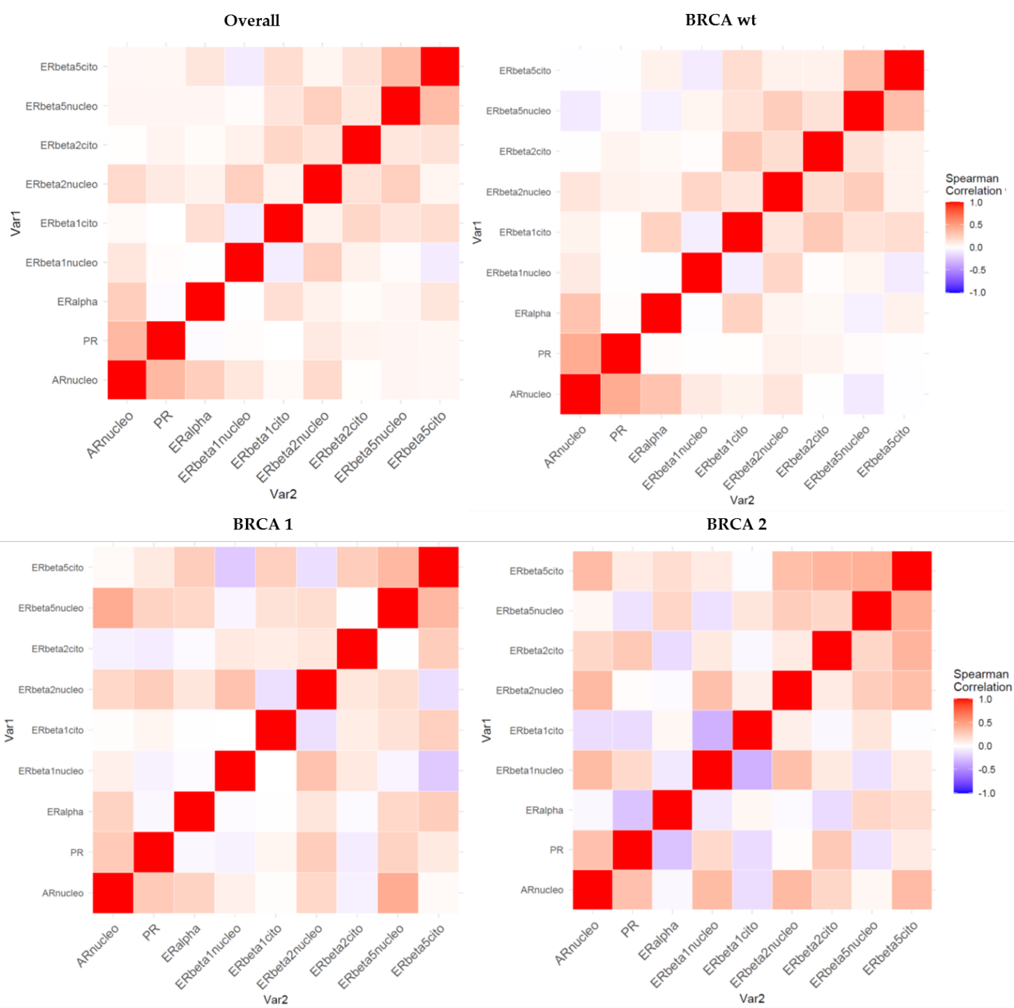

**Figure 2.** Heatmaps of the Spearman correlations, both overall and stratified for BRCA molecular pattern, i.e. BRCA wild-type; BRCA 1 and BRCA 2 (wt: wild type; AR: androgen receptor; PR: progesterone receptor; ER: oestrogen receptor)**.**

|  |  |  |  |  |
| --- | --- | --- | --- | --- |
| **Supplementary Table 3.** General characteristics of the study population according to BRCA wt and BRCA mutated (1 or 2) (n=202).* | | | | |
|  | **Overall** | **BRCA mutation** | | |
|  |  | **wtBRCA**  **(n=132)** | **BRCA 1 or 2**  **(n=70)** | **p\*\*** |
| Age (yrs.) | 59.1 (11.5) | 60.5 (11.4) | 56.5 (11.1) | **0.012** |
| Nucleus AR score | 0 (0-2) | 0 (0-2) | 0 (0-2) | 0.821 |
| PR score | 1 (0-3) | 1 (0-2.5) | 1 (0-4) | 0.145 |
| ER-α score | 4 (2-8) | 4 (2-8) | 3 (1-6) | 0.139 |
| Nucleus ER-β1 score | 4 (3-8) | 5 (3-8) | 4 (3-8) | 0.218 |
| Cytoplasm ER-β1 score | 3 (0-3) | 3 (0-3) | 2 (0-3) | 0.519 |
| Nucleus ER-β2 score | 8 (4-8) | 7.1 (3.3) | 6.9 (3.3) | 0.535 |
| Cytoplasm ER-β2 score | 2 (0-3) | 2 (0-3) | 2 (0-3) | 0.509 |
| Nucleus ER-β5 score | 6 (4-8) | 6.3 (2.8) | 5.8 (3.3) | 0.155 |
| Cytoplasm ER-β5 score | 0 (0-3) | 0 (0-3) | 0 (0-3) | 0.799 |
| ER-α/Nucleus ER-β1 ratio | 0.8 (0.4-2.0) | 0.9 (0.3-2.0) | 0.8 (0.4-1.2) | 0.784 |
| ER-α/Nucleus ER-β2 ratio | 0.7 (0.3-1.1) | 0.7 (0.3-1.3) | 0.7 (0.3-1.0) | 0.737 |
| ER-α/Nucleus ER-β5 ratio | 0.8 (0.3-1.3) | 0.8 (0.3-1.3) | 0.8 (0.4-1.5) | 0.505 |
| **Abbreviations**: wt: wild-type; AR: androgen receptor; PR: progesterone receptor; ER: oestrogen receptor;  * Descriptive statistics are expressed as median (interquartile range) or mean (standard deviation)  ** p-values were computed by Student t test (if normally distributed) or Mann Whitney U test | | | | |

|  |  |  |  |  |  |  |  |  |  |
| --- | --- | --- | --- | --- | --- | --- | --- | --- | --- |
| **Table 4. Association analysis of the molecular markers stratified according to BRCA molecular pattern, both overall and in BRCA-wt and BRCA mutated (BRCA 1 or BRCA 2) (n =202).** | | | | | | | | | |
| **OVERALL** | **Nucleus AR score** | **PR score** | **ER-α score** | **Nucleus**  **ER-β1 score** | **Cytoplasm**  **ER-β1 score** | **Nucleus**  **ER-β2 score** | **Cytoplasm**  **ER-β2 score** | **Nucleus**  **ER-β5 score** | **Cytoplasm**  **ER-β2 score** |
| **PR score** | **0.369 (0.242; 0.506)**  **<0.001** | - |  |  |  |  |  |  |  |
| **ER-α score** | **0.255 (0.130; 0.377)**  **<0.001** | -0.017 (-0.161; 0.126)  0.809 | - |  |  |  |  |  |  |
| **Nucleus ER-β1 score** | *0.13 (-0.002; 0.248)*  *0.070* | 0.017 (-0.120; 0.149)  0.809 | -0.004 (-0.130; 0.134)  0.959 | - |  |  |  |  |  |
| **Cytoplasm ER-β1 score** | 0.031 (-0.112; 0.170)  0.666 | -0.000 (-0.141; 0.142)  0.995 | **0.170 (0.031; 0.299)**  **0.015** | -0.081 (-0.228; 0.064)  0.249 | - |  |  |  |  |
| **Nucleus ER-β2 score** | **0.192 (0.045; 0.320)**  **0.006** | 0.108 (-0.038; 0.270)  0.127 | 0.071 (-0.085; 0.196)  0.317 | **0.249 (0.115; 0.383)**  **<0.001** | 0.073 (-0.057; 0.202)  0.296 | - |  |  |  |
| **Cytoplasm ER-β2 score** | 0.007 (-0.125; 0.139)  0.915 | 0.056 (-0.090; 0.191)  0.428 | 0.021 (-0.110; 0.153)  0.761 | 0.073 (-0.064; 0.198)  0.305 | **0.208 (0.073; 0.343)**  **0.003** | **0.152 (-0.005; 0.286)**  **0.031** | - |  |  |
| **Nucleus ER-β5 score** | 0.052 (-0.090; 0.186)  0.466 | 0.046 (-0.093; 0.188)  0.513 | 0.045 (-0.091; 0.173)  0.521 | 0.019 (-0.122; 0.169)  0.790 | **0.139 (0.003; 0.278)**  **0.048** | **0.250 (0.108; 0.367)**  **<0.001** | *0.127 (-0.014; 0.267)*  *0.071* | **-** |  |
| **Cytoplasm ER-β5 score** | 0.040 (-0.101; 0.188)  0.574 | 0.041 (-0.100; 0.201)  0.558 | *0.132 (0.008; 0.260)*  *0.061* | -0.085 (-0.218; 0.054)  0.226 | **0.179 (0.035; 0.310)**  **0.011** | 0.053 (-0.086; 0.193)  0.457 | **0.154 (0.011; 0.290)**  **0.028** | **0.347 (0.222; 0.467)**  **<0.001** | **-** |
| **wtBRCA (n=132)** | | | | | | | | | |
| **PR score** | 0.429 (0.261; 0.579)  **<0.001** | - |  |  |  |  |  |  |  |
| **ER-α score** | 0.314 (0.169; 0.454)  **<0.001** | 0.014 (-0.151; 0.188)  0.869 | - |  |  |  |  |  |  |
| **Nucleus ER-β1 score** | 0.108 (-0.054; 0.261)  0.219 | -0.004 (-0.174; 0.162)  0.964 | -0.013 (-0.187; 0.157)  0.879 | - |  |  |  |  |  |
| **Cytoplasm ER-β1 score** | 0.064 (-0.121; 0.230)  0.487 | 0.007 (-0.163; 0.187)  0.932 | **0.238 (0.074; 0.393)**  **0.006** | -0.073 (-0.259; 0.114)  0.406 | - |  |  |  |  |
| **Nucleus ER-β2 score** | 0.138 (-0.040; 0.304)  0.114 | 0.072 (-0.109; 0.250)  0.414 | 0.056 (-0.123; 0.219)  0.525 | **0.215 (0.039; 0.365)**  **0.013** | 0.136 (-0.015; 0.293)  0.121 | - |  |  |  |
| **Cytoplasm ER-β2 score** | -0.005 (-0.183; 0.174)  0.954 | 0.059 (-0.101; 0.230)  0.501 | 0.034 (-0.132; 0.195)  0.701 | 0.017 (-0.147; 0.181)  0.849 | **0.280 (0.121; 0.435)**  **0.001** | **0.175 (-0.014; 0.348)**  **0.045** | - |  |  |
| **Nucleus ER-β5 score** | -0.087 (-0.247; 0.076)  0.319 | 0.021 (-0.155; 0.187)  0.815 | -0.062 (-0.231; 0.095)  0.478 | 0.055 (-0.110; 0.227)  0.534 | *0.149 (-0.025; 0.316)*  *0.087* | **0.263 (0.083; 0.417)**  **0.002** | *0.153 (-0.017; 0.319)*  *0.079* | - |  |
| **Cytoplasm ER-β5 score** | -0.010 (-0.184; 0.175)  0.909 | -0.003 (-0.198; 0.172)  0.968 | 0.072 (-0.088; 0.218)  0.412 | -0.084 (-0.253; 0.088)  0.337 | **0.176 (-0.020; 0.337)**  **0.043** | 0.075 (-0.096; 0.242)  0.392 | 0.068 (-0.092; 0.238)  0.438 | **0.337 (0.174; 0.472)**  **<0.001** | - |
| **BRCA mutated (n=70)** | | | | | | | | | |
| **PR score** | **0.277 (0.039; 0.502)**  **0.020** | - |  |  |  |  |  |  |  |
| **ER-α score** | 0.124 (-0.111; 0.338)  0.307 | -0.067 (-0.314; 0.164)  0.582 | - |  |  |  |  |  |  |
| **Nucleus ER-β1 score** | 0.162 (-0.090; 0.384)  0.179 | 0.083 (-0.149; 0.298)  0.495 | -0.008 (-0.274; 0.241)  0.945 | - |  |  |  |  |  |
| **Cytoplasm ER-β1 score** | -0.045 (-0.285; 0.208)  0.711 | -0.003 (-0.243; 0.258)  0.981 | 0.047 (-0.191; 0.286)  0.700 | -0.107 (-0.337; 0.111)  0.382 | - |  |  |  |  |
| **Nucleus ER-β2 score** | **0.268 (0.022; 0.498)**  **0.025** | 0.173 (-0.046; 0.383)  0.152 | 0.080 (-0.167; 0.314)  0.510 | **0.304 (0.061; 0.506)**  **0.011** | -0.049 (-0.299; 0.169)  0.688 | - |  |  |  |
| **Cytoplasm ER-β2 score** | 0.036 (-0.201; 0.291)  0.769 | 0.065 (-0.150; 0.319)  0.590 | -0.027 (-0.275; 0.206)  0.825 | 0.184 (-0.044; 0.415)  0.127 | 0.078 (-0.184; 0.322)  0.519 | 0.118 (-0.108; 0.339)  0.329 | - |  |  |
| **Nucleus ER-β5 score** | **0.274 (0.033; 0.494)**  **0.022** | 0.117 (-0.111; 0.342)  0.333 | *0.221 (-0.011; 0.444)*  *0.067* | -0.070 (-0.305; 0.183)  0.562 | 0.119 (-0.145; 0.383)  0.328 | *0.213 (-0.052; 0.468)*  *0.077* | 0.081 (-0.153; 0.288)  0.507 | - |  |
| **Cytoplasm ER-β5 score** | 0.126 (-0.114; 0.361)  0.298 | 0.118 (-0.138; 0.359)  0.331 | **0.259 (0.038; 0.451)**  **0.030** | -0.070 (-0.280; 0.134)  0.563 | 0.191 (-0.029; 0.424)  0.113 | 0.012 (-0.237; 0.242)  0.918 | **0.322 (0.077; 0.541)**  **0.007** | **0.382 (0.162; 0.570)**  **0.001** | - |
| * Correlations are expressed as follows: r= Spearman correlation coefficient (95% confidence interval) and p-value. In bold the significant results (p<0.05), in italic the suggestive results (0.05<p<0.10).  ** (wt: wild type; AR: androgen receptor; PR: progesterone receptor; ER: oestrogen receptor). | | | | | | | | | |

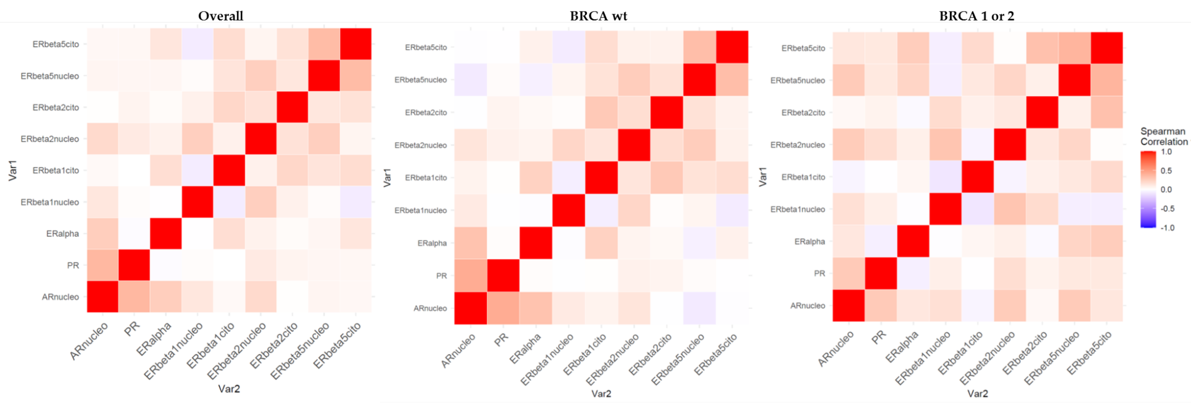

**Figure 3.** Heatmaps of the Spearman correlations, both overall and stratified for BRCA molecular pattern, i.e. BRCA wild-type and BRCA mutated (BRCA 1 or BRCA 2 (wt: wild type; AR: androgen receptor; PR: progesterone receptor; ER: oestrogen receptor)**.**

**Discussion**

**…**

**Conclusions**

…

**Acknowledgments**

…

**Author Contributions**

Conceptualization: …

Investigation: …

Data curation: …

Methodology: DG PCP LG

Formal analysis: DG PCP

Project administration: …

Funding acquisition: …

Resources: …

Supervision: …

Writing – original draft: DG PCP …

Writing – review & editing: …

**Disclosure**

…

**References**

R Core Team (2020). R: A language and environment for statistical computing. R Foundation for Statistical Computing, Vienna, Austria. URL <https://www.R-project.org/>.

Frank E Harrell Jr, with contributions from Charles Dupont and many others. (2021). Hmisc: Harrell Miscellaneous. R package version 4.5-0. <https://CRAN.R-project.org/package=Hmisc>

H. Wickham. ggplot2: Elegant Graphics for Data Analysis. Springer-Verlag New York, 2016.